
OHS TRAINING SPECIALIST


APD INDUSTRIAL PARK, 41 ELSECAR STREET, KAY SANDS, RANDBURG, 2188

OCCUPATIONAL HEALTH AND SAFETY TRAINING

"ZERO COMPROMISE TOWARDS SAFETY"


Table of Contents
About Us 01
Basic OHS Act Legal Liability 03
Health and Safety Representative 04
Hazard Identification and Risk Assessment 05
Emergency Preparedness and Evacuation Procedures 06
Introduction to Basic Fire Fighting 07
First Aid Level 1 08
First Aid Level 2 and 3 09
Incident Investigation 10
Supervisory OHS 11
Environmental Awareness 12
Stacking and Storage 13
COID 14
Root Cause Analysis 15
Asbestos Abatement Regulations 16
Regulations for Hazardous Chemical Agents 17
Hazmat Awareness 18
SANS 10400 19
Sprinkler Systems 20
Ergonomics Workshop 21
Confined Spaces 22
Growth Rings Consulting Training Centre 23
Contact Us 24


OHS

Course

BASIC OHS ACT LEGAL LIABILITY

4 Hours

This workshop is structured to ensure a full understanding of legal liabilities and responsibilities, for managers who are usually answerable for the health and safety of others.
On this workshop, you will learn:
Introduction to the Occupational Health and Safety Act 85 of 1993 Structure of the Act
Specific sections of the Civil and Criminal Liabilities Health and Safety Act 85 of 1993
Basic regulation requirements Important definitions
Legal duties
Basic Hazard Identification and Risk Assessment requirements Offences and Penalties 03


OHS

Course

HEALTH & SAFETY REPRESENTATIVE

2 Days

This course provides an outline of some of the main areas that will fall within the responsibilities and functions of the nominated, elected and appointed SHE Representative, including workplace inspections
On this course you will learn:
Introduction to the occupational Health & Safety Act 85 of 1993 Duties and responsibilities of the employer and employees Functions of a health and safety representative
Development and functions of a health and safety committee Inspection process (theory)
Inspection process (practical)

04

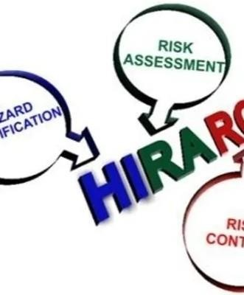
OHS

Course

HAZARD IDENTIFICATION & RISK ASSESSMENT

2 Days

This course provides an outline of some of the main areas that will fall within occupational health, safety hazard identification and risk assessment as well as environmental aspect and impact assessments, includes a practical risk assessment.
On this course, you will learn: Hazard and risk terminology Methodologies Understanding the Risk Matrix
Hazard Classification and sources Hazard Identification
HIRA Process Hierarchy of Control
Determine the Risk Rating
Development of a Risk Register 05


OHS

Course

EMERGENCY PREPAREDNESS & EVACUATION PROCEDURES

1 Day

If you are part of the H&S team, this course will prepare you to be able to deal with different emergencies in the workplace. You will be able to assist your fellow employees, clients, contractors and visitors on your premises in case of an emergency.
On this course, you will learn:
The intention of an emergency plan Evacuation procedures
Emergency floor plans Key emergency personnel
Specific emergencies and actions Emergency telephone numbers Department / Floor / Area Sweep
Rescue Techniques 06

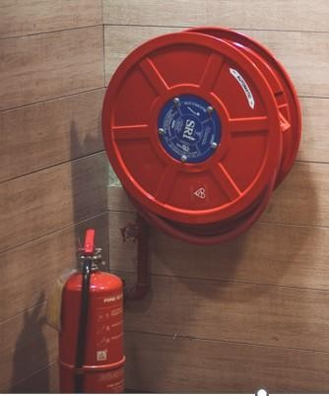
OHS

Course

INTRODUCTION TO BASIC FIRE FIGHTING

1 Day

This course is designed for persons who are required to practice fire prevention as well as identify, contain and extinguish a fire by operating basic firefighting equipment. You will understand the relationship between fire safety, fire prevention and good housekeeping in the workplace and how to correctly manage the emergency.
On this course, you will learn:
How to identify the types of fires you might encounter in your working/home environment;
Which fire extinguisher to use on each type of fire;
How to correctly and safely extinguish a fire using your available fire equipment.

07

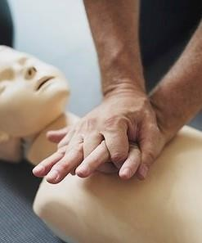
OHS

Course

FIRST AID LEVEL 1

2 Days

First Aid level 1 is the entry level course on emergency principles. You learn to perform basic life support and first aid in emergencies. The course entails theoretical knowledge as well as practical such as CPR. On this course you will learn:
Principals of emergency care, safety and emergency scene management
Artificial Respirations One Man CPR Airway Obstruction Wounds & Bleeding
Shock, unconsciousness & fainting Fractures & splinting
Burns
Head & Spinal Injuries
08


OHS

Course

FIRST AID LEVEL 2 & 3

4 Days

A combined course of First Aid level 2 & 3 is an advanced theory and practical skills emergency care course.
On this course you will learn: Chest, hand, eye injuries Multiple Injury Management Environmental Illnesses Poisoning, bites & stings Chest pain & paralyses
Fits
Management of soft tissue injuries Foreign object management
Elementary & Applied Anatomy & Physiology Emergency childbirth
Water related emergencies 09


OHS

Course

INCIDENT INVESTIGATION

1 Day

This training course is specifically aimed at employees who will be one of the first persons to arrive at an incident scene and who will be tasked with the formal investigation as legally required. Focuses on equipping SHE Representatives, supervisors, appointed incident investigators, committee members and management to deal with an occupational incident.
On this course you will learn:
The Legal Requirements for conducting investigations How to approach and conduct an investigation Practical examples of incident investigations
The standard for investigation of workplace incidents
The people, tools and equipment required to conduct the investigation Gathering and evaluation of data
Methods to gather data
Performing post investigation activities
Remedial action 10


OHS

Course

SUPERVISORY OHS

3 Days

This course is structured to ensure a full understanding of the Health and Safety Supervisors and their responsibilities. It is structured for the higher level of employee and who are usually answerable for the health and safety of others.
On this course, you will learn:
Understand the different roles of supervisors in H&S. Key functions between the supervisor and employees.
Responsibility of supervisors regarding incident reporting. Completion of Annexure 1 & WCL2 forms as per the COID Act.

11


OHS

Course

ENVIRONMENTAL AWARENESS

1 Day

This course is structured to assist with the understanding of Environmental Legal Liabilities and responsibilities.
In this course you will learn:
Identify the components of the environment and describe their interrelationships
Identify a range of impacts on the environment and use the correct terminology to describe them.
Describe natural events and human activities which result in impacts on the environment
Gather information related to a particular environmental impact on the immediate
surroundings and use it to describe the cause and effect of the impact. 12


OHS

Course

STACKING AND STORAGE

1 Day

On this course you will learn about the safe stacking and storage of documents, boxes, equipment etc. Learn the basic principles and legal requirements of stacking and storage?
On this course, you will learn:
The legal requirements as per the OHS Act
Able to identify hazards with regards to stacking and storage Precautions to take with stacking & storage operations
General requirements regarding positioning, size, stability and segregation when stacking & storing components, practical inspections and written reports.

13


OHS

Course

COID COMPENSATION FOR OCCUPATION INJURIES AND DISEASES ACT

1 Day

Your company must register with Compensation for Occupational Injuries and Diseases (COID). It’s a legal requirement!
On this course, you will learn
How your company registers for COID. How your company can pay for tariffs
How your company can claim compensation for employees who've contracted disease or been injured on duty.

14


OHS

Course

ROOT CAUSE ANALYSIS

1 Day

Root Cause Analysis is a method used to address a problem or non- conformance, in order to get to the “root cause” of the problem. RCA is a tool designed to help identify not only what and how an event occurred, but also why it happened.
On this course, you will learn: What is Root Cause Analysis. Root Cause Analysis definitions.
Philosophy of Root Cause Analysis. Symptom approach.
Five major steps. Brainstorming. The “5 WHY’S”.
Problem solving. 15

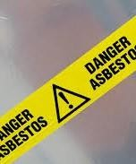
OHS

Course

ASBESTOS ABATEMENT REGULATIONS

1 Day

The duty of care an employer holds towards their employees to protect them from asbestos exposure and to provide information, instruction and training on asbestos is not a new one, this is carried over from the previous Asbestos Regulations, along with the requirement to keep records.
On this course, you will learn: What is Asbestos.
Asbestos Types
Asbestos Related Diseases Asbestos Regulations Asbestos Management Asbestos Work
Penalties 16


OHS

Course

REGULATIONS FOR HAZARDOUS CHEMICAL AGENTS

1 Day

Every employer who undertakes work which is liable to expose an employee to an HCA must, before any employee is exposed to the workplace, provide employees with suitable and sufficient information, instruction and training.
On this course, you will learn: Hazardous Chemical Agents
UN Globally Harmonized System (GHS) Definitions
Exposure Controls Monitoring Controls Regulations

17

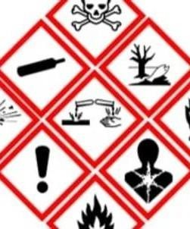
OHS

Course

HAZMAT AWARENESS

1 Day

The most important aspect of chemicals is identifying the substance, and how it will affect human health, property and the environment.
On this course, you will learn:
Identification and Classification of Dangerous Goods Hazards Associated with Dangerous Goods Personal Protective Equipment
Safe Handling of Flammable Substances Spillage Control
Formulating a Response Plan

18

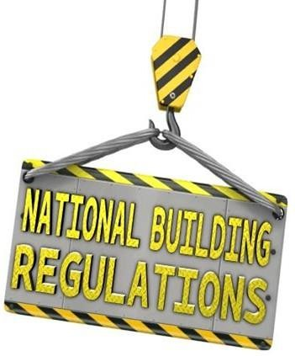
OHS

Course

SANS 10400

4 Days

On this course you will gain a holistic view of the application of the National Building Regulations. You will learn some of the fundamentals of the NBR and the elementary applications thereof.
On this course, you will learn:
General principles and requirements Part A - XA
Structural Design, Public Safety, Site Operations, Excavations, Foundations, Floors, Walls, Roofs, Stairways, Glazing, Lighting and Ventilations, Drainage, Non-water-borne means of Sanitary Disposal, Stormwater Disposal, Facilities for Persons with Disabilities, Fire Protection, Space Heating, Fire Installation, Environmental Sustainability and Energy Usage in Buildings
19

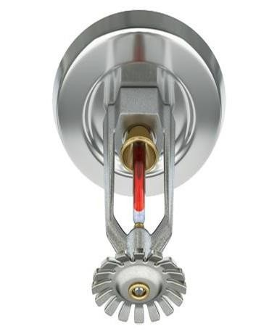
OHS

Course

SPRINKLER SYSTEMS

1 Day

On completion of the course the learner will be able to:
Understand how sprinklers are designed and how different types of sprinkler heads work.
Understand how fire loads are calculated.
Understand water supply requirements and how effective capacity of tanks is calculated.
Know maintenance required for various parts of the sprinkler installation.

20


OHS

Course

ERGONOMICS WORKSHOP

1 Day

Workplace ergonomics is the science of designing the workplace, keeping in mind the capabilities and limitations of the worker. A workplace ergonomics improvement process removes risk factors that lead to musculoskeletal injuries and allows for improved human performance and productivity.
On completion of the course the learner will be able to:
To understand the principles behind the Ergonomic Regulations 2019, No. R 1589 as published in December 2019.
To know how to implement Ergonomics into your workplace based on the day-to-day activities of interaction of humans to the tasks that they conduct
21

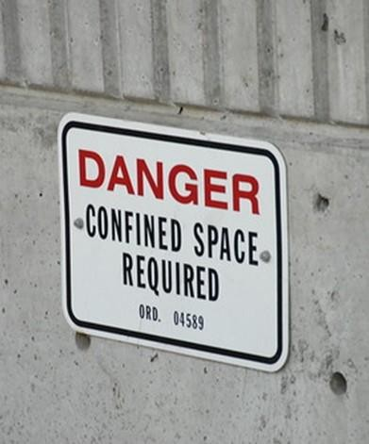
OHS

Course

CONFINED SPACES

1 Day

Understand the principles and procedures behind a safe entry into confined spaces and declaring the space safe to enter.
On this course, you will learn: Types of confined spaces Confined space hazards
Safe entry into confined spaces Permit system
Precautionary measures

22


GROWTH RINGS CONSULTING
Training Centre

Growth Rings Consulting Training Centre is an environment that promotes learning and keeps delegates engaged. Our classroom can accommodate up to 15 delegates per Classrooms. Tea and coffee refreshments are available at our coffee station in the break-away room.
Catering can be arranged at an additional charge.
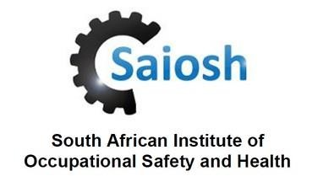

23

10

Contact Us

010 023 7331 / 082 049 7255

Info@grconsult.co.za

www.grconsult.co.za

APD Industrial
Park, 41 Elsecar Street, Kay sands
Randburg
2188 24

